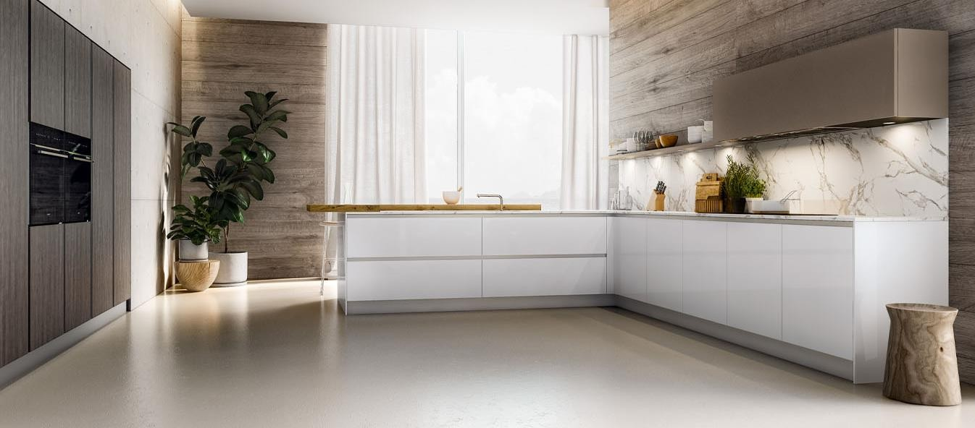
Villa Mango

Villa Chinola

ANTLANTICA Italian modular kitchens

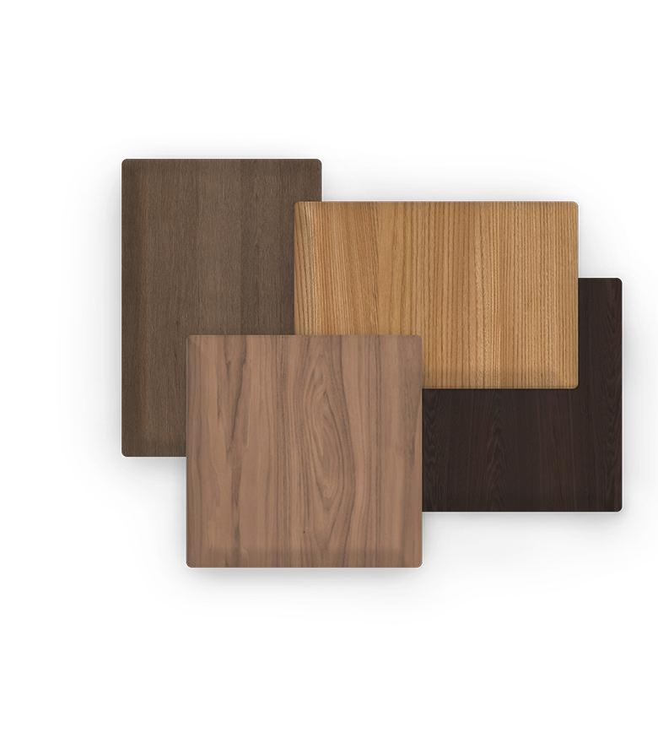
Wooden doors, in addition to being the result of careful selections of solid wood panels and profiles, are also the result of another construction technology that guarantees their stability over time. The elegance of the surface veinsis and the natural style of this material makes it imperishable, only the colors evolve and Armony offers different ranges of flared, wavy and dentellados oak veneers. The paint, in addition to accentuating the surface geometries, protects from thewear of time and maintains its unchanged appearance.

Materials

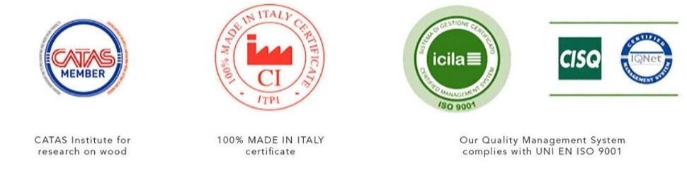
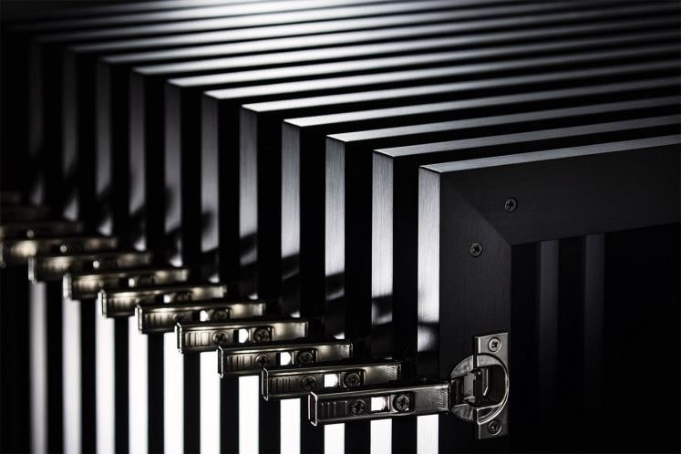
Armony is a kitchen in which all wood components come from forests in which strict environmental, social and economic standards are applied that respect and will respect current and future generations .

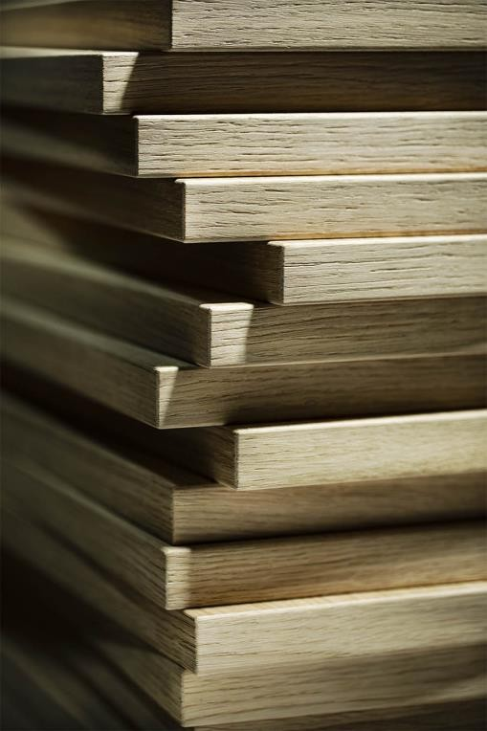
The elegance of the surface veins and the natural essence of the authentic wood make it an imperishable material. Only the colors evolve and Armony offers different options of flamed oak veneers with a veined or serrated appearance finish. The paint, in addition to enhancing the geometries of the surface, protects from the wear of the roofand maintains its unchanged appearance.

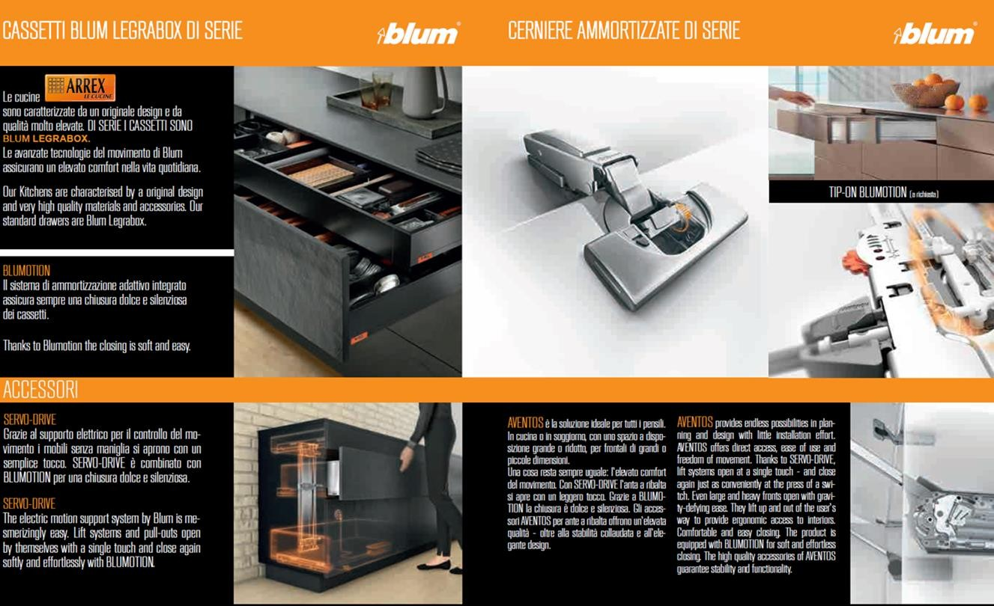
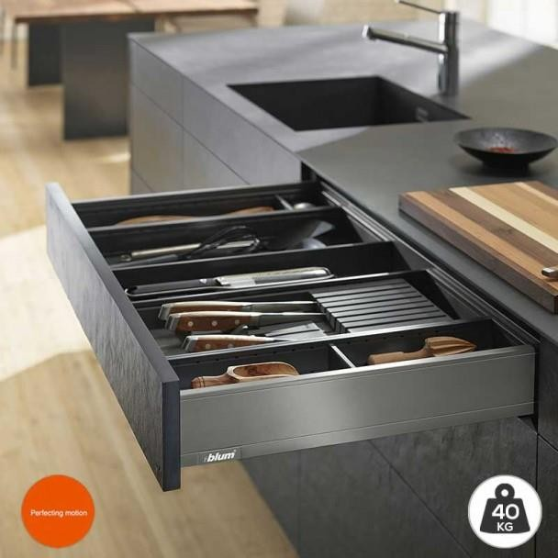
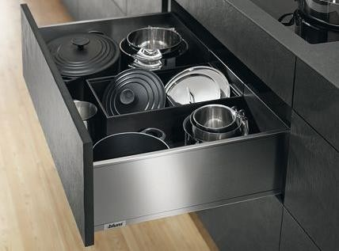

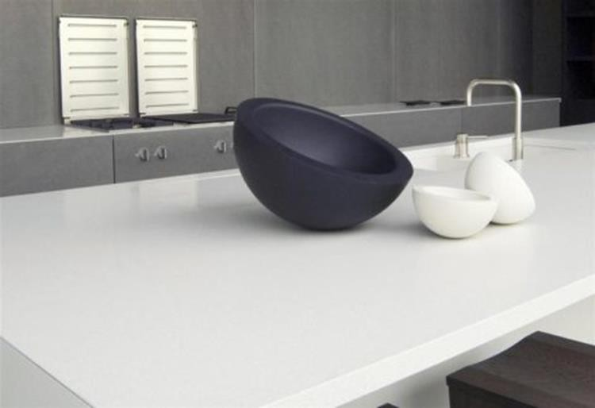
Because you'll love SM Quartz surfaces

Created from carefully selected quartz sands and resins that undergo an intense machining, calibration and polishing process, SM Quartz materials are in line with the strict international standards required forfood industry and for use indoors and home environments.

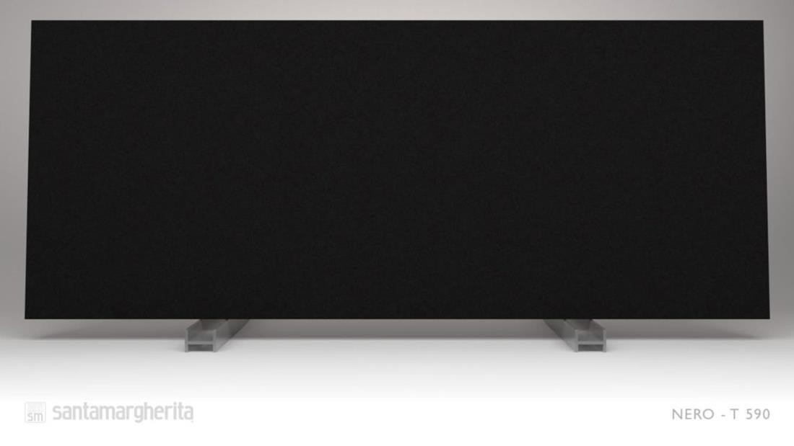
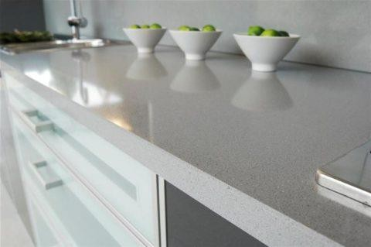
Resistant to scratches, stains
and heat.
SM Quartz caps are characterized by high scratch resistance, low water absorption and high resistance to chemicals. Food will not leave stains on the counter.

The polishing of Santamargherita surfaces is unparalleled: the material is stain-resistant and does not retain dirt, which makes the countertop very easy to clean. Glossy quartz surfaces are non-porous and are highly resistant to liquids and acidic substances such as coffee, wine, lemon juice, olive oil, vinegar, and cosmetics.

Colors

Kappa sílice matt Rho cashmere

Clay

ANCIENT ANTL
White top zenith SP: 2cm

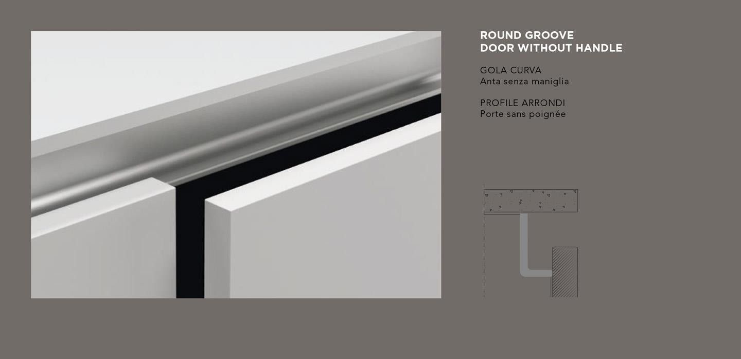
Type of Opening

ANCIENT ANTL

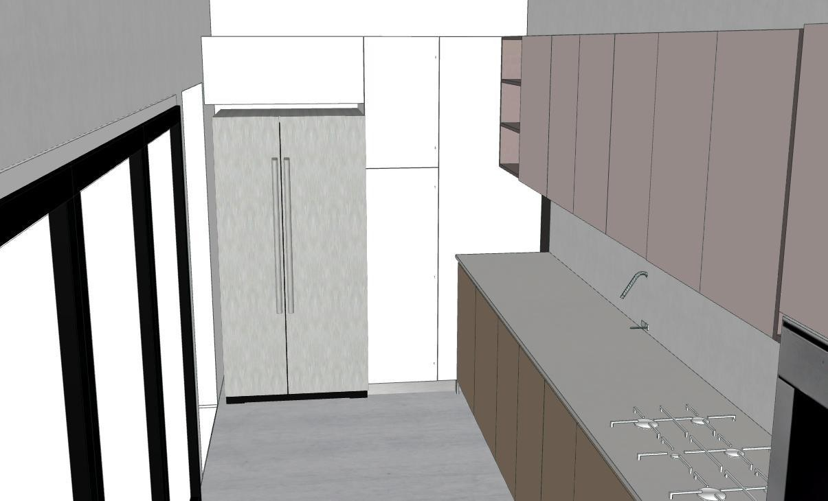
ANCIENT ANTL

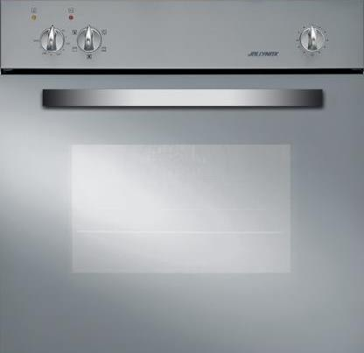
HORNO LIFE 60 CM

ANCIENT ANTL
STOVE LIFE 4 FIRES

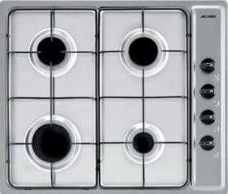

MOD GREASE EXTRACTOR
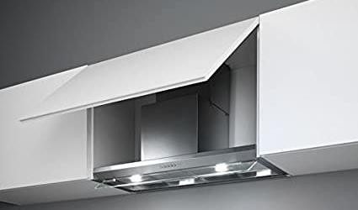
COMMA

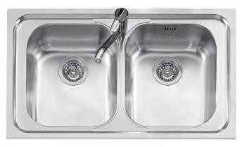
SINK MOD LIFE 86X50 2
MOUTHS

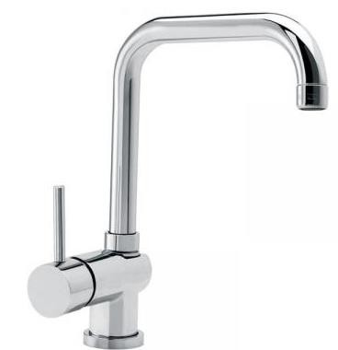
MOD MIXER
PICTURE

